CRICOS NO. 02696B

Carnegie Mellon Heinz College Australia

News Detail

The GFC Effect
Release Date: Aug 18, 2011 | Author: Susan Peterson, Carnegie Mellon University - Australia

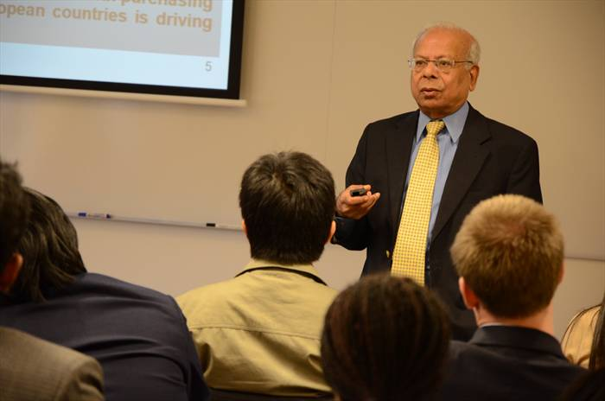
Dr Ishrat Husain presents at Convocation.
On Tuesday 16 August, Dean and Director at the Institute of Business Administration (IBA) Karachi, Dr Ishrat Husain, hosted Convocation for students, faculty and staff from Carnegie Mellon University – Australia.
Dr Husain has served in the Civil Service of Pakistan in policy making, the Finance, Planning and Development departments, and has also served at the World Bank as an Economist in the West African Programs Department.
During his Convocation titled Differentiated Impact and Response of the Global Financial Crisis, Developing and Developed Countries, Dr Husain discussed the impact of the GFC, global economies two years on and the outlook for the future.
“2010, two years after the crisis, was a good year because we all felt the economy was coming out of the recession,” Dr Husain said.
“The world GDP expansion rate was 5.1 per cent, primarily because of the emerging and developing economies which grew by 7 per cent, up from 2.8 per cent in 2009. But the United States (U.S.) and Europe remain a source of worry for the global economy at this moment,” he said.
Dr Husain continued to discuss how emerging and developing economies, with the exception of Central and Eastern Europe, were less affected by the GFC than developed countries.
“This crisis has hurt the rich countries, the advanced countries, more than the developing countries,” he said.
“Africa, Latin America and Asia did not suffer very much and the reason is that the regulatory and supervisory framework of the central banks or the other supervisory agencies was much stronger in the developing countries, unlike the U.S. where you have too many regulators but nobody actually calling the shots.”
“The shadow banking which was responsible for a lot of trouble in 2008 and 2009 did not exist in the developing countries,” he said.
“Also the financial sector in poorer countries did not cater to the small farmers, small scale entrepreneurs, low income housing and micro enterprises, so the crisis had no impact on the poorer section of the population because they were not part of the banking system.”
Dr Husain also highlighted the difficulties in predicting what will happen to global economies going forward.
“Unfortunately I don’t have a crystal ball,” Dr Husain said.
“My own assessment is that the overall situation is still very fragile, and what is happening in the U.S. and European Union is what will determine the future, not what is happening in the emerging and developing countries,” he said.
“The reason is that despite the growth which is taking place, the weight of the U.S., European Union, Japan, Australia and New Zealand in the global economy is quite high, and naturally anyone whose wager is high will be calling the shots, not the other way around.”
Back to Previous Page

