Floods: the next phase
By Ishrat Husain
Wednesday, 08 Sep, 2010
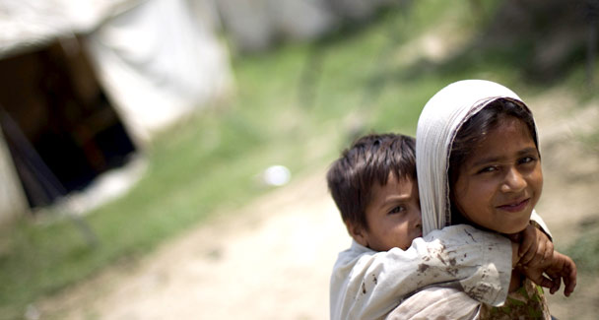
A girl carries her young brother at a relief camp in Nowshera, September 7. — Photo by Reuters
The devastation caused by the floods is unparalleled in Pakistan’s history. It has come at a time when Pakistan is already contending with the enormous losses incurred in fighting the terrorists and a global economic crisis.
No country with the resources and capacity of Pakistan could have been expected to meet the assault on the economy by these shocks. Pakistan’s response will depend upon the degree of stimulus provided by both the domestic and international community.
Over the next few months, coordinated relief efforts to provide food, safe water and hygienic living conditions will have to be accelerated. As the floodwaters recede and a more accurate picture emerges of the extent of damage, planning and preparation for the next phase, i.e. rehabilitation, the restoration of livelihood and infrastructure reconstruction should begin.
The immediate task would be to facilitate the return of approximately four million families to their respective habitats and enable them to make the transition from dependence to earning livelihoods. Cash grants, microfinance loans, the supply of seeds, fertilisers, bullocks, implements and housing material can be financed from allocations from the Benazir Income Support Programme, funds at the parliamentarians’ disposal, the People’s Works Programme, the Poverty Alleviation Fund, Baitul Mal and Zakat and provincial development budgets.
These public-sector funds should be supplemented by the corporate sector, NGOs, microfinance banks and institutions (MFBs and MFIs), civil society groups, wealthy individuals, philanthropists and expatriates. These groups may operate in specific areas or be assigned specific tasks without being asked to donate cash contributions.
MFBs and MFIs can be provided lines of credit from domestic and international donors for channelling micro loans for agriculture, housing and micro businesses. Similarly, the international donor community can undertake projects of their choice in a particular district directly or through local organisations, the only requirement being that the activities of each participating agency be part of the district rehabilitation and reconstruction programme.
There are many merits of this. First, there will be an integrated planning framework under which public sector, non-government sector, private sector and international donors will participate in a coordinated manner but with full control over their resources. Second, plans will be prepared with an intimate knowledge of local conditions — the communities displaced, the lands damaged, the livestock destroyed, the stocks of grains and seeds washed away, etc. Third, activities resulting in overlapping and duplication would be avoided.The traditional way whereby the federal or provincial government agencies formulate, approve and implement plan from the capitals is bound to result in failure, lapses or delays. The calamity-struck districts should be provided with the manpower and financial resources to prepare a plan with the help of government agencies, NGOs, the private sector and donors.
A district rehabilitation and reconstruction board, headed by the district coordination officer and comprising representatives of major participating agencies, should be formed. It should be overseen by an independent monitoring committee consisting of parliamentarians of the district, armed forces’ representatives and eminent persons hailing from the district. The provincial and federal governments and the National Disaster Management Authority should place some of their technical experts and skilled manpower at the disposal of boards on deputation.
The government should redouble its efforts to obtain access for our textile exports to the EU and US. At home, export industries should be given the support they need in the form of raw material, uninterrupted power supply, credit and logistical support. Increased export earnings can obviate the need for further loans and improve the capacity to import essentials. The national highway system should be repaired and the recommendations of the prime minister’s task force on climate change scrutinised and implemented if feasible.
At the provincial level, this crisis can be tapped for the rehabilitation and strengthening of our entire irrigation system — barrages, embankments, flood protection bunds, spurs, river training, removing obstructions from the floodplains, desilting, lining of water courses, etc. Such rehabilitation should be accompanied by the institutional overhaul of the irrigation and power departments. The post-relief phase can have a positive impact on the economy. The infusion of capital and the redeployment of millions in productive activities would stimulate the aggregate demand, promote employment and help kick-start the economy. The higher moisture retention in arid lands can boost agricultural production and ease inflationary pressure arising from the shortage of food and other commodities. In the medium to long term the efficiency of the irrigation system can pay dividends in the form of better utilisation of scarce water resources and higher yields.
The risks to the proposal are many. First, by perpetuating negative perceptions about the government, financial and human resources required from within and outside the country may never materialise. This risk has been mitigated in this proposal by bringing in each player to play its due role but, at the same time, with the independence to operate — under monitoring and accountability mechanisms.
Second, the tendency to over-centralise and the allergy to devolving power, authority and resources to those with the best awareness of the problems at hand and the solution may persist. The plan to set up the district board may be fiercely opposed by the ministers as they will lose control.
Third, we have perfected the art of going through rituals without caring for substance. It is possible that these boards are formed on paper but made toothless so that they meet the same fate as the police and public safety commissions of the previous regime.
The writer is a former governor of the State Bank of Pakistan.

