BLUE CHIP MAGAZINE, November 2012

Dr. Ishrat Husain - Dean & Director IBA

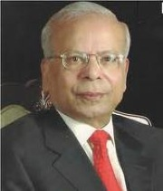 | Education
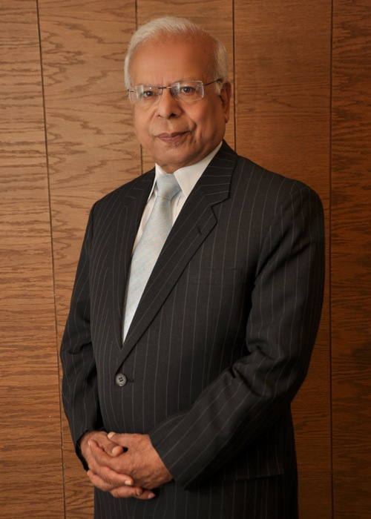
Dean of Pakistan’s iconic Institute of Business Administration (IBA), Dr. Ishrat Husain has emerged as one of Pakistan’s leading economists and intellectuals. During his term as Governor State Bank of Pakistan which commenced in 1999, he ushered in unprecedented reforms and embarked on a complete restructuring of the central bank. His tenure is widely regarded as a golden period in Pakistan’s banking history and his reforms have received acknowledgement from the World Bank and IMF as among the best in the developing world. The Banker Magazine, London declared him the Central Bank Governor of the year for Asia in 2005.
In recognition of his services to the country, he was awarded the Hilal-e-Imtiaz by the President of Pakistan in 2003. His books and articles on economic development continue to receive international acclaim. Infusing IBA with innovation and dynamism, he talks to Mashaal Gauhar about his vision to transform IBA into a world-class institution and shares his views on education and economic development in Pakistan and the region.

Since your appointment as Dean and Director of IBA in 2008, the institution has seen great reform and development, what is your vision for IBA?
“As you know, IBA is the oldest business school established outside North America. It has produced 10,000 alumni who are occupying very important positions as chief executives in multinationals and Pakistani companies here as well as abroad but somehow it has not made a mark as far as the global business schools are concerned. One of the reasons I accepted this challenge was to work hard to take it to the tier of the top 100 business schools in the world.
In order to achieve that, you have to work backwards. We have implemented a five year strategic plan which consists of five pillars. The first pillar is that we should have excellence in academics and quality should be the same as the other top business schools. We should not lag behind them. The second is to have a first rate faculty in all our subjects. We have the best student body in Pakistan with the brightest students but somehow the faculty was not of the same calibre. Our endeavour is to attract the best teachers from Pakistan and all over the world to boost our faculty. The third pillar is to have a state-of-the-art physical infrastructure because over the last 40-45 years the student body has expanded from 200 to 2,000 but there has been no addition to classrooms, seminar rooms, laboratories, hostels – faculty members didn’t even have a place to sit – so we are investing a lot in physical infrastructure. Along with the physical infrastructure is the IT enable infrastructure: our whole student body is connected through telephony, internet, video conferencing, we have broadband wireless on the campus, remote access available to the students and faculty , a vibrant ERP system, e-journals and e-books, we are investing in anything which can enable the students and teachers to use IT tools to improve their learning environment. The fifth is that we believe IBA should be of service to the community in which it works and we have the Centre for Entrepreneurship Development, the Centre for Executive Education, the Centre for Business & Economic Research so the corporate sector and industry can benefit from the expertise and discipline heads which we have accumulated at IBA. This five pillar strategy started in 2009 and will end in 2014.”
What are your views on the state of education in the country?
“My personal view is that there has been some improvement in higher educational institutions during the last 10 years since the Higher Education Commission (HEC) was established, but college education is not very satisfactory. The teachers at the college level are not very committed to their profession and because they are not committed to their profession, they do not take much interest .Sometimes they do not turn up – and sometimes they come and repeat the same notes which they prepared several years ago. So the students are not actually benefitting from this education. All our attention, rightly so, has been on primary education and university education. But we are missing this important link which is college education because we are producing unemployable graduates who do not have any skills that equip them for finding jobs in this economy. These will be very frustrated and disillusioned young men and women. We are doing a great disservice by not paying attention to college education.”
Can you elaborate on the importance of entrepreneurship for Pakistan’s youth?
“So far we have been producing the executives for multinational corporations. But with the youth bulge we need to have three million jobs every year. So we have to find ways in which one graduate of the business school can create at least ten jobs. You cannot do this if you go for nine to five employment, so by setting up the Centre for Entrepreneurship Development, we are encouraging our graduates to set up their own businesses and we will provide them with the skills, knowledge and seed money in order to start their business. Some will succeed and others may fail but at least they will try again and success will come their way – the multiplication effect will be quite high.
So for the future, we have to change our strategy from creating employment for multinational companies and Pakistani companies only into a mix that also includes self-employment and new enterprises which are set by our graduates. We are beginning to do that through our close collaboration with Babson College in Boston which has been for many years the number one entrepreneurship school in the world. We are very fortunate to benefit from this synergy and partnership with Babson College.”
IBA is emerging as a forum for international speakers and thinkers, is this part of your plan to enhance IBA’s standing as a world-class institution?
“Absolutely. So far I have noticed that the students are very much inward looking: they are always looking inside Pakistan. But in a globalised world you must have a more broad-based outlook; you should know what is happening in the rest of the world; you should learn about other nations and cultures because at some point of time you will have to interact with them. Bringing in international teachers, international business people, thinkers and intellectuals is to provide students with the opportunity to be exposed to the best people in the world. I have also made one foreign language compulsory for every student, they have a choice of Chinese, French or Arabic. We also teach them the culture of China, Francophone Africa and the Middle East so that they have an understanding of other parts of the world and we hope that will be of some value to them.”

How does IBA ensure the inclusion of low-income students through the National Talent Hunt Programme?
“I am a strong believer in providing and expanding the set of opportunities for upward social mobility to the talented young men and women of this country who are bright and intelligent but they do not have the financial means to improve themselves. In this culture of kinship, biradari, nepotism and sifarish this is hard to do but we should not give up. Under the National Talent Hunt Programme we select talented students from the backward districts of Pakistan, bring them to Karachi where they live in hostels and are not only given tutorials and lectures but we also teach them how to dress up, how to interview, how to make presentations, so we prepare them for the entrance test of IBA and the interviews at IBA. Those who are selected through an open, competitive examination system are assured four years full financing including monthly pocket money which we provide to them. So everything is taken care of. I am very happy that last year out of forty students who appeared at the test through the National Talent Hunt programme, 17 of them were able to clear our test and get admission into IBA. That gives me greatest pleasure. If you ask me what is the one thing that gives me the most satisfaction as the head of IBA, it is the National Talent Hunt Progamme.”
You have worked extensively on Pakistan-India economic relations, do you see bilateral trade improving?
“That is what our entire effort is at this moment. India and China are the two fast growing economies in the world and we are located between these two countries so we should be able to take advantage of this location because the contiguity to these countries opens up big markets for us. If we are able to penetrate India and China, the benefits will accrue to us. It is in the interest of smaller countries to take advantage of their location to do business and trade with larger countries. Canada is a small country and its prosperity has been driven by its economic ties to the US. Mexico was a very poor country but after joining the North America Free Trade Agreement (NAFTA) the Mexican economy is growing very rapidly because they have access to the US market. My view is that we should penetrate and access both the Chinese market as well as the Indian market as we will be the beneficiary of this trade.”
You have also written extensively on how Pakistan’s geo-strategic location has been more problematic in the past that it has been beneficial, can you expand on this?
“I feel that for the last 30 years we have been involved in Afghanistan first in collaboration with the US to get the Soviets out of Afghanistan and by promoting the Mujahideen in Afghanistan we created problems for ourselves. By supporting the Taliban regime we spread Talibanisation in the country. Because of the war in Afghanistan, Kalashnikovs and drugs spilled over. We had three million refugees from Afghanistan who we have had to feed, clothe and shelter. With the US involvement in the war on terror, some people in Pakistan feel that this did not have a very positive effect on us. In fact it has been a negative spillover because the costs we are incurring are huge. Our society is in turmoil, there are suicide bombings, people are fearful and scared, our business relationship with the rest of the world has been affected as people do not come to Pakistan, export orders are cancelled, insurance premiums are high and the tourist trade has dried up. These are the costs we are paying for our participation in the war against terror.”
Do you see greater South Asian regional integration advancing?
“I think it will if we sincerely implement the South Asia Free Trade Agreement (SAFTA) and sort out our problems with India I am sure that the other countries in the region will be very happy with this development because Pakistan and India account for 90% of the regional economy. If you have good relations between Pakistan and India, the rest will follow. I am quite optimistic that if Pakistan and India are successful in their economic relations, we will have a very economically vibrant South Asia.”
As one of Pakistan’s leading figures, what advice would you give to young people?
“I have always said that there are no shortcuts in life. You have to work hard, you have to work with honesty and you have to work with a sense of commitment throughout your life. You will be tempted on many occasions to cut corners and take shortcuts. If you do that you may gain temporarily but in the long run you will fall by the wayside; if you remain steadfast and adhere to your values and your high ethical standards, I can assure you that you will come out successful.”
You have emerged as a role model for many people but who have been your role models?
“My role model in life has been Quaid-e-Azam Muhammad Ali Jinnah because there has been no individual who despite such adverse circumstances was able to create a nation. That achievement is unparalleled in history. That shows if you are committed to a cause and you work hard towards it, nothing can stop you.”

By

Mashaal Gauhar

