Home Companies Markets Industry & Economy Opinion Features Today Topics
Investment World Smartbuy eWorld BrandLine Mentor New Manager Life Brand Quest

Pak MBAs head for Wall St
Rasheeda Bhagat
Share · Comment · print · T+ T+ · T-

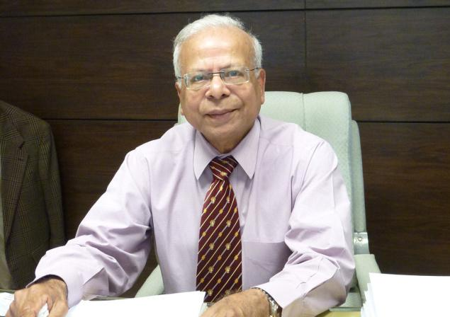
Dr Ishrat Husain , Dean and Director, Institute of Business Administration, Karachi. - Rasheeda Bhagat
Unlike Indians pursuing research, they choose to make millions.
Unlike many Indian management graduates who opt for doctorates, their Pakistani counterparts don't believe in “wasting” four more years and opt for Wall Street jobs, where they can make millions of dollars, says Dr Ishrat Husain, Dean and Director, Institute of Business Administration (IBA), Karachi in an interview to Life. Excerpts:
Tell us about the state of higher education in Pakistan and why prestigious institutions like yours or LUMS (Lahore University of Management Studies) have not been replicated.
Higher education being given some importance is a very recent phenomenon in Pakistan. But we do have some islands of excellence such as the Agha Khan University in Medical Sciences. But yes, we need 10 times more such institutions.
We face two issues; being a newcomer to higher education, I've discovered that unlike India, which has 175 Indian academicians serving as faculty in top business schools in the US, we don't have any such asset. That is a big problem; even if we had 17-20 such people working abroad we could have leveraged them to create faculty for higher education here. Pakistanis, by nature, are not very interested in long-term investment in higher education. They do their MBAs from Harvard and want to go straight to Wall Street and earn millions. They tell me: ‘Look, if we spent another four years doing our PhD we'd have foregone millions of dollars of bonuses and salaries. And if we join academia after four years, we are not going to get enough.' So it is the thinking which is low. But India, South India in particular, compared to Pakistan, has a very deep-rooted tradition of research and development, not only in business, but also engineering and sciences.
And that provides you a strong platform on which your IITs, IIMs, engineering colleges and other fine institutions can be sustained. We don't have such a platform. But now we're working on it. The higher education commission, which was established in the early 2000s, is sending faculty members for PhDs. When this lot returns, we'll have to catch up. But the catching-up will be huge. You have 10-12 per cent of enrolment ratio in tertiary education; we have only 5-6 per cent. So in the numbers too, you're producing millions of graduates every year. Private education becomes viable if there is volume. Look at the Gulf States; they have established branches of Northwestern, Carnegie Melon and London School of Economics, but they don't have the volume of students to sustain them. India has that advantage.
You have very bright and hard-working students, and the volumes which enable the private sector to play an important role. Look at the ISB in Hyderabad. It was a purely corporate sector initiative and the model is to bring Northwestern, Kellogg, Wharton faculty to the ISB; they replicate those courses for a month and go back. You're getting the best of education from top schools, a luxury we don't have. This, to me, is a major shortcoming of the higher education scene in Pakistan.
I'm told you've made a sea change in three years at the IBA. What have been your priorities, challenges?
I came with a mission. I don't need a job… I've been the governor of the central bank (State Bank of Pakistan), so I thought I'd do something that gives me satisfaction. Education is my passion, and I thought with my connections and contacts I should be able to make a humble contribution to business education, provide some talent for the sector. Because, in a globalised world we can't live with our heads in the sand. My aim was to make IBA the best business school in Pakistan and one among the top 100 schools globally.
What was your vision, plan for this?
My strategic plan was based on five pillars. The curriculum and academic quality should be of the best B-schools in the world. We've revamped our undergrad and graduate programmes with the help of an international advisory council comprising the deans of the best global B-schools.
They're not Pakistanis?
No. This has elevated our degree programme. To do that, we needed a very high-calibre faculty. My aim is to have 90-95 per cent faculty members with PhDs, or (those who are) chief executives, COOs, chief marketing officers, so they can bring in real-world experience to the classroom. Three, the physical infrastructure facilities had outlived their utility, as they were built in the 1960s for 200 students and 20 teachers. Now I have 200 teachers and 2,000 students. We had to restructure and modernise classrooms, computer labs, library, hostels, auditoriums, and so on. And the Government's fiscal condition was not very good, so I had to raise money from the corporate sector and individual philanthropists.
Was raising the fee not an option?
The fee is already high at Rs 2.5 lakh per semester (four months). We couldn't raise it further; from a target of Rs 460 crore, we've collected Rs 300 crore. We have 9,000 alumni all over the world and they are contributing too. Just like your IITs, we are creating student loans too, and also have financial aid programmes for poor students.
Doesn't the Government give loans for higher education here?
No. But we're doing that. I've made sure no student who gets admission is denied education here because of financial resources. One-third of my students are getting some financial aid; sons of office assistants and daughters of policemen are also studying here.
Then I introduced a national talent hunt programme to get students from rural and backward areas. About 80 students from such areas who have done well in their intermediate exams are given a two-month intensive training at IBA — tutorials, interview sessions, presentation skills — and then they take the entrance exam. About 15 of the 80 make it; these are boys and girls who haven't stepped out of their villages.
Next is tech upgrade. In today's world, if I can't get international faculty members physically, let me do it via videoconferencing and other such learning tools. We are setting up a centre for entrepreneur development; we equip you with skills to set up enterprises to create jobs, rather than get a job with an MNC. Last, wanting to be useful to the community, we have a high-geared executive education programme for the corporate, non-profit and public sectors. We're also going to have a joint programme with the ISB.
I go to India often for conferences, and want to have student exchange programmes. My pet theme is: Next door we have such fine educational institutions, where even American students come for exchange programmes, so why can't we do so too? I'm working on this, but the visa regime has to be relaxed. Some friends from India are willing to give lectures at IBA, but if it takes two months to get visas, they have no time. So I'm talking to the Foreign Ministers — yours and ours — to have a separate visa regime for academics. Investing in the younger generation, which has no baggage of history, will pave the way for better understanding and relations between the two countries.
rasheeda@thehindu.co.in
Keywords: Institute of Business Administration (IBA), Karachi, Lahore University of Management Studies, management education, Wall Street jobs, B-schools

