THE EXPRESS TRIBUNE June 1, 2013

Short-run governance reforms
A rebalancing of powers among the premier/chief minister, minister, and secretary has to be worked out immediately.
By Ishrat Husain
Published: May 31, 2013
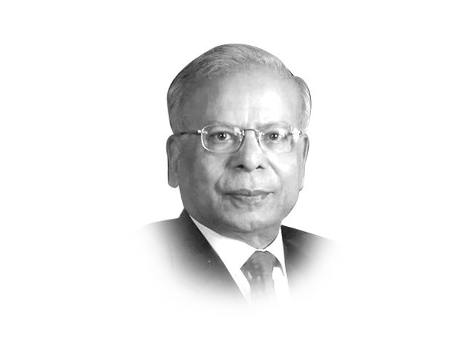
The writer is dean and director of IBA, Karachi. He also served as governor of the State Bank of Pakistan from 1999 to 2005
The newly-elected government in Pakistan can bring about a significant and perceptible change in the governance structure if it is able to announce and implement a few critical changes in the existing system. The impact of these changes will be huge, both in the actual functioning of our institutions, as well as in altering the perception of the public-at-large. The preparatory work for these reforms has already been completed after wide consultations and only needs to be reviewed and approved by the cabinet.
First, the security of tenure for all government officers should be introduced and observed in letter and in spirit. If a secretary is appointed for a term of three years and a SHO for a term of two years, they cannot be transferred arbitrarily at the whims and caprices of the competent authority. The reasons for removal should be reduced in writing and the affected person will have the right to challenge this decision as a justiciable right. The Supreme Court has already given its verdict on this issue in the Anita Turab case. All that is required is to comply with it in the future.
This will impose an obligation upon the authority to carefully select the person suitable for the job, to agree on the performance indicators and to monitor the progress against these objective indicators. The present practice, where as many as 14 secretaries were appointed and transferred in a period of five years, has led to demotivation, demoralization, political alignments, corrupt practices and poor outcomes. Lack of continuity of the Principal Accounting Officers and absence of any checks upon their performance are the root cause of poor governance.
Second, the rules of business confer enormous discretionary powers upon the prime minister and the chief ministers. In a parliamentary system, the cabinets are responsible for collective decision-making. As practiced, the present system has made the ministers ineffective in exercising their powers as all summaries have to be approved by the chief executive. A rebalancing of the powers among the Prime Minister (PM)/chief minister, minister and secretary has to be worked out immediately to curb this unhealthy tendency of excessive concentration of powers in one hand. All eyes are cast and all approaches are made to a single individual negating the accepted principles of collective decision-making and delegation of powers.
Third, a corollary to the excessive concentration of powers in the hands of the PM/chief minister has been the dominance of the principal secretary to the Prime Minister (PSPM)/chief minister as the most powerful individual in the government. These parallel secretariats in which all the summaries/proposals submitted by the line ministries/departments are again reviewed by junior officials of the PM secretariat need to be trimmed down to a few experienced officers/advisers in the PM’s office. There is no need to second guess the judgment and wisdom of the secretaries to the government.
Unlike the provinces, the federal government does not have an officer equivalent to the chief secretary who can coordinate among different ministries of the government and also act as the head of the civil service. This role used to be played by the cabinet secretary in the past but has been weakened over time with the gradual empowerment of the PSPM. There is a need to appoint the senior most civil servant as the cabinet secretary, who will play the coordinating role and also look after the welfare and problems faced by the civil servants. The Secretaries Committee should also be revived to decide on inter-ministerial issues that are now routinely taken by the cabinet and committees of the cabinet.
The fifth step is to weed out and purge all the existing manuals and rule books of the redundant and superseded rules, circulars, directives and instructions. An exercise was done for Estacode and an updated Establishment Manual has been prepared. The ministry of finance has also updated all the Financial Rules. Uploading of these manuals and rules on websites of the respective ministries/departments will go a long way in bringing about transparency and reducing the discretionary powers of the lower functionaries. Some corrupt practices take place because the information about rules and regulations is hoarded by a few individuals who take advantage of this opacity for their self-aggrandizement. An open and transparent system will help minimize these practices.
Sixth, the system of financial advisers (FA) for each ministry in the federal government has proved to be a major stumbling block in orderly decision-making and efficient utilization of budgetary resources. The FA office virtually enjoys the veto power in matters of expenditure and although the secretary is accountable for results, he or she cannot do very much as overruling the FA will invoke a lot of sanctions. The replacement of FA by chief finance and accounts officers is old wine in the new bottle. The training, mindset and skills of these officers have to be altered. Eligibility criteria and job descriptions should be drawn out for these jobs and suitably qualified persons appointed to these positions with specific terms of reference.
Seventh, the process of appointing chief executives of important public enterprises should be streamlined. The CEOs and the board members should be selected by a search committee consisting of eminent persons of repute in their respective fields. They should specify the eligibility criteria, conduct proper tests and interview candidates from a pool drawn from those who have responded to advertisements and those recommended by head hunters etc. The committee will prepare a shortlist of three top candidates and the prime minister or the chief minister can select one of them. Once appointed, these chief executives and the board members will enjoy a fixed tenure and cannot be removed arbitrarily. They will be held accountable for results based on agreed performance indicators.
Eighth, the National Accountability Bureau and the provincial anti-corruption bureaus, along with the prosecutor general staff, should be made autonomous. Officers of highest integrity and competence should be inducted and the appointments of the head of these bureaus should be made jointly by the government and the opposition parties. They should be reporting to the parliament and the provincial assemblies.
Ninth, the Government of Punjab has introduced a Freedom of Information Act which will make information about public policy available to the general public. The transparency thus achieved will act as a brake on the exercise of discretionary powers for their personal benefits by the decision-makers. Media and judiciary can then take action against those found indulging in nepotism and favoritism. Similar legislation should be introduced at the federal and in the other three provinces.
Tenth, the Federal Board of Revenue’s powers to issues Statutory Regulatory Orders have created enormous distortions and leakages in revenue collection. These powers should be exercised by Parliamentary Committees on Finance and Revenue after open public hearings.
Published in The Express Tribune, June 1

