THE AFPAK CHANNEL

Don't Disturb the Consensus
BY ISHRAT HUSAIN | DECEMBER 18, 2013

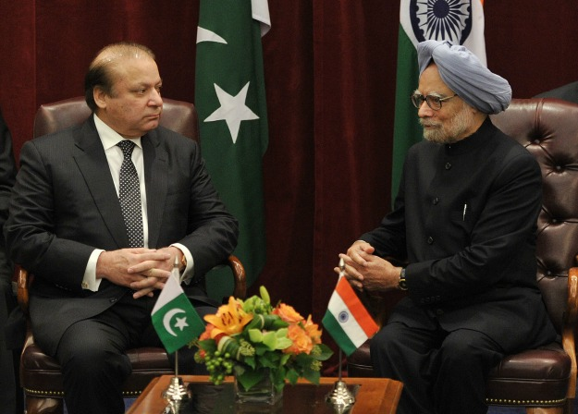

Pakistani Prime Minister Nawaz Sharif and his Indian counterpart, Prime Minister Manmohan Singh, met in New York on the sidelines of the U.N. General Assembly meeting in September. While many hoped it would signal a fresh start in Indo-Pak relations, it proved to be a missed opportunity for the two countries to get their bilateral relations back on track. The much awaited resumption of composite dialogue was never announced.
Very few people realize the sea change towards India that has taken place in Pakistan in the post-2001 period. The Pakistan army, no doubt the most powerful institution in Pakistan and also the main arbiter of its foreign policy, has finally realized that Pakistan's biggest threat is internal and no longer India. This shift in Pakistan's one-dimensional, India-centric outlook is significant and emerged after much deep introspection.
Evidence of this recalibration appeared in 2011 when the military voice its support for the previous government's efforts to grant "Most Favored Nation" (MFN) trade status to India and relax the visa regime to promote people-to-people exchanges between the two countries. Unfortunately, the effort failed due to Pakistan's powerful agricultural lobby. After the government agreed to phase out a list of goods that could not be imported from India (known colloquially as "the negative list") by December 31, 2012, the agricultural lobby stepped in, arguing that India's heavy agricultural subsidies, higher tariffs, and sanitary standards to control plant diseases would act as a barrier for Pakistani exports. It claimed that Pakistan would be inundated with subsidized Indian food and grains, harming the livelihoods of Pakistani farmers.
As the 2013 general elections in Pakistan approached last May, the rural members of the parliament forced the government to delay phasing out the negative list, thus denying India MFN status. Sharif's government remains openly committed to phasing out the list, but it feels aggrieved by India's lukewarm response to its proposals to resume the composite bilateral dialogue, of which trade normalization is one component. A joint India-Pakistan Business Council has been formed to reach an understanding on the contentious issues raised by both sides, but progress has so far been slow and lackluster. While Pakistan should have conferred MFN status upon India nearly two years ago, it should certainly do so now without further delay. With the army's support, the government still has the ability to do so.
All the major political parties -- the Pakistan Peoples Party, the Pakistan Muslim League, the Pakistan Tehreek-e-Insaaf, the Awami National Party, and the Muttahida Qaumi Movement -- have publicly committed to normalizing relations with India, strengthening trade and economic ties, and intensifying personnel exchanges. These sentiments even found their way into the parties' respective campaign platforms. Sharif has been a consistent and ardent advocate of better ties with India, to the chagrin of some of his closest aides.
Support for rapprochement outside the government has also grown. Pakistani media, otherwise known for its boisterousness, has begun to take a more sober view of India-Pakistan relations and anti-India rhetoric has dimmed. Public opinion polls show that the general population now considers terrorist elements operating in the country, not India, to be Pakistan's number one enemy. And the Pakistani business community, with a few exceptions, remains the biggest advocate and supporter of removing tariff and non-tariff barriers and increasing trade facilitation measures with India. These business organizations argue persuasively that a smaller economy such as Pakistan will benefit from closer ties to its larger neighbor. Such ties would give Pakistani consumers access to cheaper medicines and other products, while producers would obtain raw materials and inputs at lower prices that would make them more competitive in many lines of goods and services.
This hard-earned consensus in Pakistan is still fragile, however. It remains vulnerable to disruption by the venomous reactions of Indians, particularly the media, to recent events such as the death of Indian citizen Sarabjit Singh in a Pakistani prison in May or ceasefire violations along the Line of Control in Kashmir this fall. This backlash unwittingly plays in the hands of those hardliners in Pakistan who aim to unravel the bonhomie between the two countries. Indian media outlets, in their ongoing ratings wars, attempt to outdo each other by exuding poison against Pakistan, causing Pakistan-bashing in India to often assume hysteric proportions. The media influences public opinion in subtle and gradual ways, and iterations of these negative views on Facebook and Twitter add fuel to the fire. In an election year, Indian opposition parties find it convenient to use a heavy stick against the ruling party and criticize its weak stance against their "enemy."
These attacks put the Indian government on the defensive, lest it antagonize a public already indoctrinated against Pakistan. The result is that the Indian government has played hardball and dragged its feet in resuming the dialogue. While Indian Prime Minister Manmohan Singh is a sincere believer in better ties with Pakistan, he faces a multitude of other domestic issues and strong opposition from others in his party and the establishment. This is unfortunate. Amid strained relations, engagement and conversation are necessary to cool heated temperatures and remove misunderstandings; it is not a time for withdrawal and disengagement.
Meanwhile, hardliners and detractors in Pakistan are using India's official reaction to argue vociferously that their country is losing its self-respect and is bending over backwards to appease an unfriendly India. Those who believe strongly in the normalization of relations, both for improving the economic welfare of the poor in the two countries and as a stepping stone for durable peace, are forced to retreat and often labeled "Indian agents."
At some point, the public pressure may become so intense that this political consensus, achieved after such a long time and buttressed by the military, may break down. Jihadist elements and the Pakistani Taliban have already declared that, in case of war against India, they will fight alongside the Pakistani army. This would pacify the Afghanistan-Pakistan border areas, allowing the army to move its troops along Pakistan's border with India. If this happens, tensions between the two nuclear-armed neighbors could escalate and a region of the world with a long history of hostility could become violent.
The eruption of violence on the subcontinent could have consequences too terrible to imagine. Clearly, it is in the interest of global leaders to ensure that the two prime ministers agree to resume their bilateral dialogue and pick up economic relations and people-to-people exchanges. Preemptive collective efforts, rather than adopting a "wait and see" approach, are needed at this juncture to avoid the looming clouds of doom and gloom.
Ishrat Husain is the Dean and Director of the Institute of Business Administration in Karachi and is Chairman of the Global Advisory Council on Pakistan at the World Economic Forum.

STAN HONDA/AFP/Getty Images

http://southasia.foreignpolicy.com/posts/2013/12/18/dont_disturb_the_consensus#sthash.2JGxXa99.e7sukzmb.dpuf

